Strabane Controlled Primary School

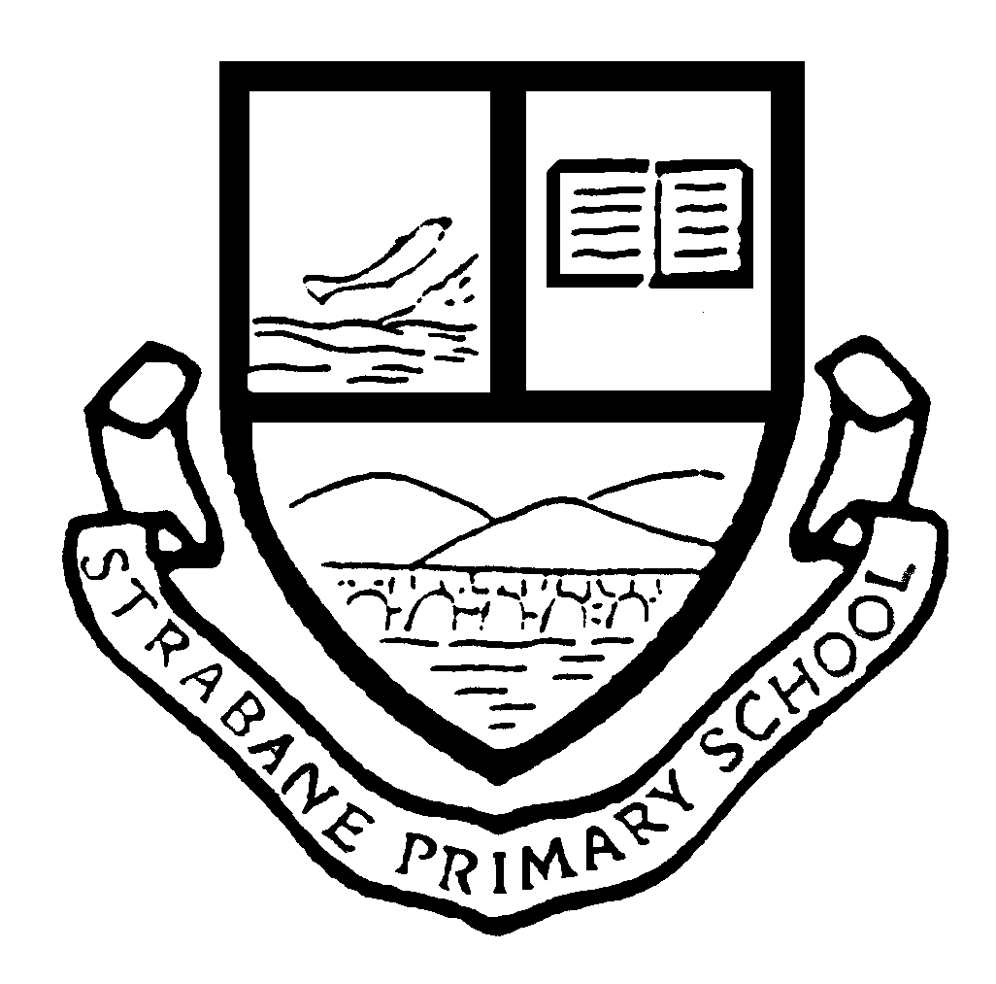

SOCIAL MEDIA POLICY
Date approved by
Board of Governors: 3rd October 2017

Review Due: October 2020

Date approved by
Board of Governors: 11th Feb 2020
Next Review Due: Feb 2023
Date approved by
Board of Governors: 3rd October 2017

Review Due: October 2020

Date approved by
Board of Governors: 3rd October 2017

Review Due: October 2020

STRABANE CONTROLLED PRIMARY

SOCIAL MEDIA POLICY
Overview
Social networking sites such as Facebook, Twitter, Instagram and other similar online forums are now widely used and these types of media allow people to communicate in ways that were not previously possible. Unfortunately, such sites can be used inappropriately by some as a means of expressing negative or offensive views about schools and their staff. This document sets out our approach to use of such sites and sets out the procedures that will be followed and action that may be taken when it is considered that such facilities have been used inappropriately.
Objectives
The purpose of the policy is to:
- Encourage social networking sites to be used in a beneficial and positive way,
- Safeguard pupils, staff and anyone associated with the school from the negative effects of social networking sites,
- Safeguard the reputation of the school from unwarranted abuse on social networking sites
- Clarify what the school considers to be appropriate and inappropriate use of social networking sites,
- Set out the procedures the school will follow where it is considered that inappropriate or unlawful use of social media networking sites is to the detriment of the school, staff, pupils or anyone else associated with the school,
- Set out the action the school will consider taking if there is inappropriate use of social networking sites.

Appropriate use of social networking sites
The school recognises that many parent and other family members will have personal social networking accounts which they might use to discuss/ share views about school issues with friends and acquaintances.
Please contact the school to discuss any concerns you may have.
Inappropriate use of social networking sites
The school considers the following examples to be inappropriate uses of social networking sites. (This list is non-exhaustive and intended to provide examples only)
- Naming children or posting any comment about children who attend Strabane Primary School and Nursery,
- Making allegations about staff or anyone else connected to the school,
- Making any posts that could be deemed to be cyber-bullying,
- Making complaints about the school or staff at the school,
- Making defamatory statement about the school or the staff at the school,
- Posting negative or offensive comments about staff or any other individual connected to the school,
- Posting racist comments,
- Posting comments which threaten violence,
- Posting comments or engaging in online discussions with children other than their own.
Parents should also ensure that their children are not using social networking and other internet sites in an inappropriate manner. It is expected that parents/ carers explain to their children what is acceptable to post online. Parents/ carers are also expected to monitor their children’s online activity, including in relation to their use of social media. Please note that most sites require the user to be at least 13 years old.

Procedure the school will follow if inappropriate use continues
The school will always endeavour to deal with concerns raised in a professional and appropriate manner. Therefore, as a first step the school will usually discuss the matter with the relevant people to try and resolve it and to ask that the inappropriate content be removed from the social networking sites. The school will consider taking the following action:
- Take legal advice and/ or legal action where the information posted is defamatory in any way or if the circumstances warrant this,
- Set out the school’s concerns to the person in writing, requesting that the material in question is removed,
- Contact the police where the school feels it appropriate – for example, if it considers a crime (such as harassment) has been committed or in cases where the posting has a racial element, it is considered to be grossly obscene, grossly offensive or is threatening violence,
- If the inappropriate comments have been made on a school website or online forum, the school may take action to block or restrict that individual’s access to that website or forum,
- Contact the host/ provider of the social networking sites to complain about the content of the site and ask for removal of the information,

Further guidance can be obtained from
- Strabane PS ICT policy – Use of the Internet
- Strabane PS Child Protection Policy
- Strabane PS Code of Conduct for Staff and pupils
This policy will be reviewed regularly.

