## Education Authority Western Region

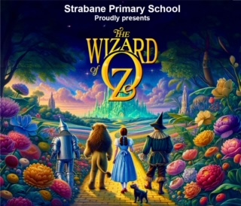

**STRABANE CONTROLLED PRIMARY SCHOOL**

# 43 Derry Road

Strabane

Co. Tyrone

#### BT828DX

Tel. (028) 71 382510

Fax. (028) 71 382525

1st December 2023

**Principal Mrs. C Thompson**

**Re. Information letter regarding the Pantomime**

Dear Parents/Guardians,

**Tickets**

* Tickets for the pantomime showings will go on sale on **Monday 4th December 2023 at 10am**.
* Tickets will be sold **online** with a NO maximum purchase. You can buy as many tickets as you wish.
* **The online portal address will be shared on Monday morning.**

**Tickets will be released at 10am on Monday morning.**

* Tickets are **£7** each.
* Once you have purchased your tickets online, the PTFA will collate the tickets and send them home to you via your child.
* Tickets will not be seat allocated, when you arrive on the day, you can choose your seat.
* Showings as follows:
* **Friday 15th December doors open at 12.20pm, showing at 12.45pm including instrumentalists.**
* **Monday 18th December doors open at 12.30pm, showing at 1pm**
* **Tuesday 19th December doors open at 12.30pm, showing at 1pm**

Please note that our instrumentalists will play before the pantomime on Friday 15th December. The pantomime will also be professionally recorded on Friday 15th. Digital copies of the recording will be available to purchase after the showings.

**Disability access**

Please continue to purchase your tickets in the same manner online for these seats. You must then make the school office aware of the need for special access so that arrangements can be made.

**Raffle**

The PTFA are also organising a raffle this year which will be conducted in school and on the night of the shows. Tickets are priced at £1 each.

**Collection**

All pupils can be collected by from the junior playground at the end of the show at approximately 3pm. Only staff and pupils are permitted to enter the classrooms.

**Thanks, and encouragement!**

Thank you to all the pupils, staff, parents and volunteers who are working so very hard to produce our much-loved annual pantomime. There is a great buzz and excitement amongst the pupils as they look forward to presenting ‘The Wizard of Oz’ to you all. I know you will encourage and help your children to learn their songs and lines at home. We look forward to welcoming you to this year’s pantomime and to see our pupils shine on stage.

**Snack and drink**

You may wish to send a drink and a snack for your child on each of these days to sustain them for the afternoon on these three school days.

**App**

Please ensure you have downloaded the School App icon as displayed.

Go to the App store on your phone

Select Strabane Primary School

You will now have access to all media via the school website and app.

Thank you.

Yours faithfully,

Mrs. C Thompson